ARTICLE VI
Compensation & Benefits

- 2023-2024 Teachers' Salary
  - Salary Schedule Increase: The 2023-2024 Teachers' Salary Schedule shall reflect an a eight two six percent (8 2 6%) increase over the 2022-2023 Employees' Salary Schedule, effective July 1, 2023 for unit members employed by the district as of the date of ratification of the tentative agreement by both parties and a one-time one two percent (1 2%) off schedule payment for unit members who are in active status as of May 1, 2024 and do not receive an increase due to the salary restructure.
  - Appendix H (Certificated Special Salaries and Stipends, including Hourly, Adult Education) shall be increased by eight two seven percent (8 2 7%) effective July 1, 2023. This increase shall be effective prospectively for work performed beginning with the first day of the month following ratification by both parties.
  - A restructured salary schedule (Exhibit A) shall be implemented effective July 1st, 2023. A restructured salary schedule (Exhibit A-1) shall be implemented effective July 1, 2024. The value of this restructured schedule is approximately equal to a .5% salary increase. A restructured Salary schedule (Exhibit A.1.1) shall be implemented retroactively to July 1, 2023.

- 2024-2025 Teachers’ Salary
  - Salary Schedule Increase: The 2024-2025 Teachers' Salary Schedule shall reflect a two five percent (2 5%) increase over the 2023-2024 Employees' Salary Schedule, effective July 1, 2024 for unit members employed by the district as of July 1, 2024 and a one-time one percent (1%) off schedule payment for unit members who are in active status as of May 1, 2025.
  - Appendix H (Certificated Special Salaries and Stipends, including Hourly, Adult Education) shall be increased by two percent (2%) effective July 1, 2024
  - A restructured salary schedule (Exhibit A) shall be implemented effective July 1st, 2023. A restructured salary schedule (Exhibit A-1) shall be implemented effective July 1, 2024. The value of this restructured schedule is approximately equal to a .5% salary increase. A restructured Salary schedule (Exhibit A.2) shall be implemented effective July 1, 2024.
  - In the case that property taxes are higher than a 2% projected increase of the 2024-25 property taxes from the 2023-24 actuals, PAUSD will provide 100% of the additional revenue to PAEA and CSEA in the form of a salary increase %. This increase would be paid in May 2025 and retroactive to July 1st, 2024.

C. Benefits
1. Retirement and Workers’ Compensation
The District shall pay the increased employer costs of all STRS, PERS and workers’ compensation benefits during the duration of this contract.
2. Unemployment Insurance
The District shall pay the cost of this item, if mandated by law during the duration of this contract.
3. Life Insurance
For the duration of the contract, the District shall provide life insurance coverage for active employees at the same level [Note: the new plan benefits are based on age- up to age 65, $100,000, age 65-69- $65,000, age 70 and older, $50,000] and shall pay the premiums for each active employee who qualifies for full benefit coverage. The District shall pay the pro-rated premiums for active employees who work more than fifty percent (50%) but less than one hundred percent (100%), as specified in Section B.4.f.2 of this article.
4. Medical, Dental, and Vision Insurance
- The District and PAEA are committed to providing unit members with cost effective health insurance coverage with plan choices and family coverage. Therefore, they each hereby instruct their appointed representatives to the Joint Benefits Committee to explore all options, including but not limited to:
(1) Changing carriers
(2) Changing coverage levels
(3) Changing rate structures
(4) Changing eligibility requirements
To achieve our joint goal, the Committee shall make every reasonable effort, depending upon obtaining information from the benefits consultants, to issue its recommendations to the parties no later than September 10th of each school year. Within two weeks of receiving a recommendation from the Joint Committee, the District and PAEA shall make every reasonable attempt to meet to negotiate this Article. The district will suspend the JBC committee during Fall, 2021 (The 2022 plan year).
B. PAUSD shall assume and pay for the full (medical, dental, vision, and life) insurance benefits with the increase cost of the medical health benefits premiums shared between the district and the employees, through contributions via automatic payroll deductions as necessary for health insurance premiums as follows instead of the language listed in the current CBA in Article VI, Compensation & Benefits, Section C, numbers 4b and 5:
1. The District shall assume and pay for the full cost of health (medical) insurance benefits provided in the Agreement for the employee only, prorated for part-time employees who work at least half-time.
2. The District shall assume and pay for ninety percent (90%) of the full cost of health (medical) insurance benefits provided in the Agreement for the employee’s dependents (i.e., one dependent or family coverage). The employee shall contribute the remaining ten percent (10%).
3. The language listed in the current CBA in Article VI, Compensation & Benefits, Section C, numbers 4d, 4e, 4f, and 4g still apply as written.

NOTE: The District proposes to continue the MOU regarding health benefits through the 2025 calendar year (see p. 86 of current contract).

- Effective January 1, 2021, and through December 31, 2021 only, the District shall contribute towards health and welfare benefits an amount not to exceed the product of $15,141 multiplied by the number of eligible employees (pro-rated to a full time equivalent assignment) for medical, dental, vision, and life insurance. Unit members who are eligible for fully paid health benefits shall participate in one of the medical programs, plus the dental, vision, and life. Full-time unit members qualified for Section B.4.e of this article may opt out of insurance.
Effective January 1, 2022, and through December 31, 2022 only, the District shall contribute towards health and welfare benefits an amount that provides unit members with the same dependent contributions from January 1, 2021 through December 31, 2021.

    - The District shall contribute up to the maximum amount listed per month toward the cost of the selected medical plan for each full-time unit member

Active Employee  Plan | District Monthly Contribution  (12 per year) | Employee Monthly Contribution  (12 per year) | Total Monthly Premium Rate for 2023
Kaiser
Employee | $ 781.32 | $0 | $ 781.32
Employee + 1 | $1,406.63 | $ 156.00 | $1,562.63
Employee + Family | $1,990.14 | $ 221.00 | $2,211.14
Sutter Health Plus
Employee | $ 899.20 | $0 | $ 899.20
Employee + 1 | $1,618.90 | $ 180.00 | $1,798.90
Employee + Family | $2,291.10 | $ 255.00 | $2,546.10
Delta Dental
PPO Plan | $ 107.46 | $0 | $ 107.46
Premier Plan | $ 128.55 | $0 | $ 128.55
VSP
Vision Plan | $ 17.56 | $0 | $ 17.56
VOYA Life Ins
Life Insurance up to  age 64 ($100,000) | $ 14.00 | $0 | $ 14.00
Life Insurance age 65  to 69 ($65,000) | $ 9.10 | $0 | $ 9.10
Life Insurance age 70  and over ($50,000) | $ 7.00 | $0 | $ 7.00
Dependent Cost | $ .24 | $0 | $ .24

- Absent any written subsequent agreement to the contrary, the District’s obligation on and after January 1, 2021, to contribute towards health benefits shall not exceed the product of $15,141 multiplied by the number of eligible employees (pro-rated to a full time equivalent assignment) divided by twelve (12) equal monthly payments. The dollar amount specified in this section sets no precedent regarding the District’s obligation to provide benefits at any particular plan level in future years. However, the District’s obligation to pay premium costs at the January 1 to December 31, 2021 level shall continue until a subsequent agreement regarding health and welfare benefits is reached or until the automatically applied $280,000 below is expended, whichever comes first.
- Beginning January 1, 2021, the District will automatically contribute $280,000 to defray any increased cost of benefits for the 2021 benefit year above the District’s contribution of the product of $15,141 multiplied by the number of eligible employees in the bargaining unit as outlined in this section.
- Agreed upon principles and procedures for calculating and allocating increased benefits costs are set forth in section B.5 of this article.
- For eligible employees whose first date of paid service is on or after January 1, 2010, the District shall provide dental insurance coverage under a PPO dental plan. Eligible employees whose first date of paid service is before January 1, 2010, the District shall provide eligible employees with a choice of dental plans--the current incentive dental plan or the PPO dental plan under which employees hired on or after January 1, 2010 are covered. Employees who have the option of selecting dental coverage and who select the PPO dental plan shall not be eligible to return to the current incentive plan. Eligible employees whose first date of paid service is before January 1, 2010, and who resign or are laid off and are subsequently rehired within thirty-nine months shall be provided only the PPO dental plan.
- The District will provide coverage to domestic partners of unit members, provided the definition of domestic partnership meets all the criteria of Section 297 of the California Family Code, and provided further that the unit member presents the District with proof that a valid declaration of domestic partnership has been filed pursuant to the above Family Code section or with any local agency registering domestic partnerships. At any time during this agreement, the carriers and the benefits specifications may be changed through negotiations if the parties mutually agree.
- Joint Benefits Committee
    - The District will form a Joint Employee-Employer Benefits Committee, comprised of four (4) appointees each of the Association, the District, and CSEA and one (1) appointee from PAMA.
    - The purpose of the Committee will be to consider and make recommendations to the negotiating teams regarding matters related to medical, dental, and vision benefits, including the following:
      - To explore alternative indemnity carriers and/or modification of current indemnity benefit specifications;
      - To recommend employment of the necessary professional advice regarding medical, dental and vision programs; and
      - To review and make recommendations on any cost savings or cost containment measures, including brokerage/sales fees, pre- and post- admissions review, contracting with local hospitals, and utilization review.
    - The respective parties will make their appointments annually by April 15 of each year. The first meeting will be scheduled by the District Human Resources Office; thereafter meetings will be scheduled by consensus of the Committee. Released time will be provided for the committee members.
- No person shall be covered under more than one plan contributed to by the District. An employee with a spouse or partner who is also employed by the District would be covered in the following manner:
      - No dependents: (a) each may be covered under employee only coverage or (b) one employee-plus-one coverage policy.
      - One or more dependents: (a) one employee-plus-family coverage policy.
      - Employee contributions: Married or registered partners, both benefit eligible and employed by the District may be eligible for an additional District contribution toward the employee contribution for health benefits in the Kaiser or Sutter Health Plus HMO employee-plus-one and the Kaiser or Sutter Health Plus HMO employee-plus-family medical coverage policies. Adding the FTE of the couple and multiplying the portion over 1.0 FTE by the District’s monthly contribution for the Kaiser or Sutter Health Plus HMO employee-only policy shall determine the amount of the additional District contribution toward the employee contribution. If this product equals or exceeds the employee monthly contribution for the chosen Kaiser or Sutter Health Plus HMO policy ($160 for the Kaiser employee-plus-one policy or $220 for Kaiser employee-plus-family policy or $150 for Sutter Health Plus HMO employee-plus-one policy or $205 for Sutter Health Plus HMO employee-plus-family policy) then the couple will not be required to pay the employee contribution. If this product does not equal or exceed the employee contribution for the chosen HMO policy then the couple will pay the difference as a monthly payroll deduction. Married or registered partners, where both are benefit eligible part-time employees, may combine their FTE to qualify for the full-time District contribution toward an employee-plus-one or employee-plus-family policy without having the District’s contribution prorated.
- Employees eligible for full-time medical coverage who provide proof of comparable medical coverage through a non-District spouse or legal partner may choose to decline District medical coverage and receive $2500 in ten (10) equal payments for a full-year of non-coverage. Employees who have declined medical benefits and received the non-coverage payment may reenroll in a medical plan during open enrollment or if a qualifying event occurs. It is within the sole discretion of the District to continue this provision for each successive year of this agreement.
- Employees eligible for full-time dental coverage may choose to decline District dental benefits and receive $300 in ten (10) equal payments for a full year of non-coverage. Employees who have declined dental benefits and received a non-coverage payment may reenroll in the Delta Dental PPO plan during open enrollment or if a qualifying event occurs. It is within the sole discretion of the District to continue this provision for each successive year of this agreement.
- Part-Time Employees
1) Employees must work one-half (.5) of a full time equivalent (FTE) position or more to be eligible for health, dental, vision and life insurance coverage.
2) For employees regularly assigned at least .5 FTE but less than 1.0 FTE, the District’s contribution for health insurance benefits (medical, dental, vision and life) shall be prorated based upon a full time assignment. If the employee elects to participate in the District’s health plans, the part time employee shall pay the balance of the premium cost through monthly payroll deductions in advance of the month of coverage.
3) Summer school employment shall not be considered for purposes of eligibility for health and welfare benefits.

5. Principles and Procedures for Calculating and Allocating Increased Benefits Costs
As part of 2019-2020 negotiations the District, Association and representatives of other District employees clarified principles and procedures for how increased benefit costs are calculated and allocated among the parties in order to implement section 4.b of this Article. These principles and procedures are reflected in the parties’ Memorandum of Understanding dated October 15, 2019, which included agreement to add language to this Article “to provide a clear and succinct explanation of how the cost of health and welfare premiums are allocated among the parties in the future.” This language is set forth below in this section.
- Beginning with the 2020-2021 District Adopted Budget, there shall be a separate budget category (“fund”) for District health and welfare benefit programs with appropriate breakdown and detail of revenues and expenditures, including a monthly accounting of employee and District contributions toward benefit costs. This fund shall be updated per established budget updates and interim reports.
- The parties will continue to utilize the Joint Benefits Committee and time lines set forth in this Article to study and make recommendations for the parties to consider in negotiations regarding increased health and welfare benefit costs.
- The data to be considered by the parties in the foregoing processes shall continue to be a so-called “Calculator” or its functional equivalent and shall include:
  - The total number of full time equivalent (FTE) employees participating in health and welfare programs as of June 30 each year (defined as medical, dental, vision and life insurance).
  - A breakdown of FTEs participating in each health and welfare program, including FTEs at each “tier of coverage,” and the corresponding cost of District and employee contributions for such coverage (per FTE rate and aggregate).
  - The number of FTEs “opting out” of District medical coverage with the corresponding individual District contribution rate and aggregate cost.
  - A breakdown of the total cost of benefits, comparing the sum of all District and employee contributions and the amount (if any) by which contributions have exceeded this total cost (the so-called “rollover”).
  - The foregoing total cost of benefits calculation shall not include estimated employee vacancies or corresponding estimated costs.
  - If there is an increase in the total cost of benefits after applying the “rollover” (if any), per past practice, the parties will meet and negotiate as necessary to allocate the increased premium costs among employees based on “tiers of coverage” and may also agree through negotiations to increase the District’s dollar contribution per eligible FTE.
      - The allocation of increased costs to employees is an additional expense that impacts employee total compensation.
      - Any increase in the District’s dollar contribution per FTE shall be considered as part of an overall increase in total compensation.

D. Salary Advancement
1. Step Advancement
Unit members (including those members with part-time assignments) who work at least seventy-five percent (75%) of the days required for their assignment shall have that year count as a year of experience for salary purposes and shall move one step on the certificated employee salary schedule. Unit members (including those members with part-time assignments) whose assignments do not span the length of a full school year shall not be eligible to move one step on the salary schedule. The District shall use both days worked and personally accumulated sick leave used during the year to calculate the number of days of service for a given school year.
2. Column Advancement
“Plan for Salary Advancement” is incorporated into this Agreement by reference as Appendix B and shall be subject to the grievance procedure, except for the section “Salary Advancement Categories.”
E. Salary Payments
The procedures in effect January 17, 1978, as outlined in Section 6 of Policy VI-E, “Compensation and Related Benefits” of the Board Policy and Procedure Manual, shall be maintained for the duration of the contract. The mileage reimbursement for approved travel will be the Internal Revenue Service rate.
F. Pre-Retirement and Post-Retirement Employment Programs
1. The “Pre-Retirement Employment and Post-Retirement Programs” are incorporated into this Agreement by reference as Appendix D.
2. Subject to Education Code Section 22119.2, the District will make the following activities creditable for STRS Defined Supplement Benefit:
a. All regular teaching beyond 1.0 FTE;
b. Stipends listed in Appendix H;
c. Summer school;
d. Academy teaching;
e. Lead teacher;
f. Hourly rate teaching;
g. Substituting during the school day;
h. Curriculum writing;
i. BTSA coach; and
j. PAR consulting teacher.
3. In addition, the Superintendent or designee and the Association President may agree during the term of this Agreement to add to the list provided the work qualifies under Education Code Section 22119.2.
4. This supplemental benefit may be taken at retirement as an additional annuity or as a lump sum payment, for purposes of paying medical benefits or any other individual use.
G. Peer Assistance and Review Program
The “Peer Assistance and Review Program” is incorporated into this Agreement by reference as Appendix E, and is subject to the grievance procedure, except for the first three paragraphs of “Program Description.”
H. Summer School Pay
The pay for summer school shall be increased by a percentage equal to the percentage increase in Appendix A, for each year of this Agreement.
I. Certificated Special Salaries
Certificated special salaries are incorporated into this agreement by reference as Appendix H.
J. Early Notice of Retirement Bonus
A permanent unit member who submits written notice of retirement to the District by February 15th of the year of retirement shall receive a bonus of $1000 for providing the District with the early notification. The bonus shall be pro-rated based upon a full-time assignment.
K. Professional Learning Stipend (PL Stipend)
The District is committed to fostering a culture of on-going professional learning in PAUSD in order to create an environment in which every staff member is actively engaged in professional learning that enhances their ability to improve the experience and education of our students. Unit members and administrators will jointly identify and provide quality professional learning opportunities focused on student learning.
  - The District shall form a committee with teacher representation to assist in identifying eligible professional learning activities and in evaluating the effectiveness of the activities. The Professional Learning Committee will consist of three (3) unit members appointed by the Association and three (3) members appointed by the District. The committee shall be responsible for:
    - Assisting in the identification of eligible professional learning activities
    - Assisting in the communication with unit members of those activities that qualify for the PL Stipend.
    - Providing feedback on the effectiveness of professional learning activities offered by the school sites and District during staff development days
- Unit members will earn the PL Stipend by engaging in 18 hours of eligible professional learning activities outside the professional workday and beyond those activities provided during designated staff development days.
- The PL Stipend will be paid at the rate published in Appendix H.
- Unit members who plan and complete 18 hours of eligible professional learning activities in a given year may earn the PL Stipend annually.
- Unit members changing grade levels, by their choice, and unit members returning from leave of absence shall be encouraged to participate in this PL program prior to the start of the school year.
- Unit members shall have their proposed professional learning activities pre-approved by their site principal using district-supplied forms. If a proposed activity is denied by the principal, the unit member may appeal the decision to the Associate Superintendent or designee.
- In extenuating circumstances, the Superintendent or Superintendent’s designee may grant a unit member an extension beyond the two-year time frame to complete the 18 hours of professional learning.
- Unit members approved by their sites for professional learning hours beyond the 18 hours needed for the PL Stipend will be paid at the hourly professional learning rate in Appendix H.
- Professional learning hours used for the PL Stipend may not be used for units to move columns on the salary schedule.
- The District has the sole discretion to discontinue the PL Stipend program (stipend and expectation of 18 hours of professional learning every two years) for any school year beyond 2015-16.

_________________________________ _________________________________
Trent Bahadursingh Date Teri Baldwin Date
Deputy Superintendent PAEA President

Current Salary Schedule for Reference:
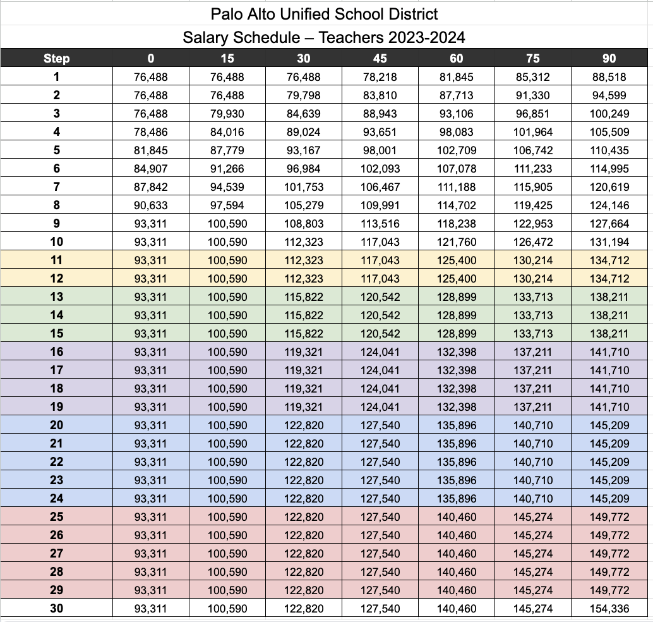

Exhibit A.1.1

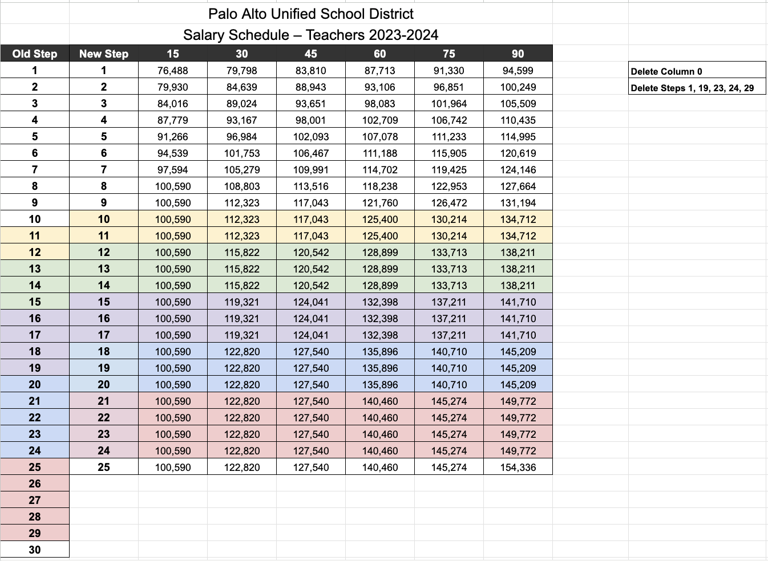

Exhibit A.2

